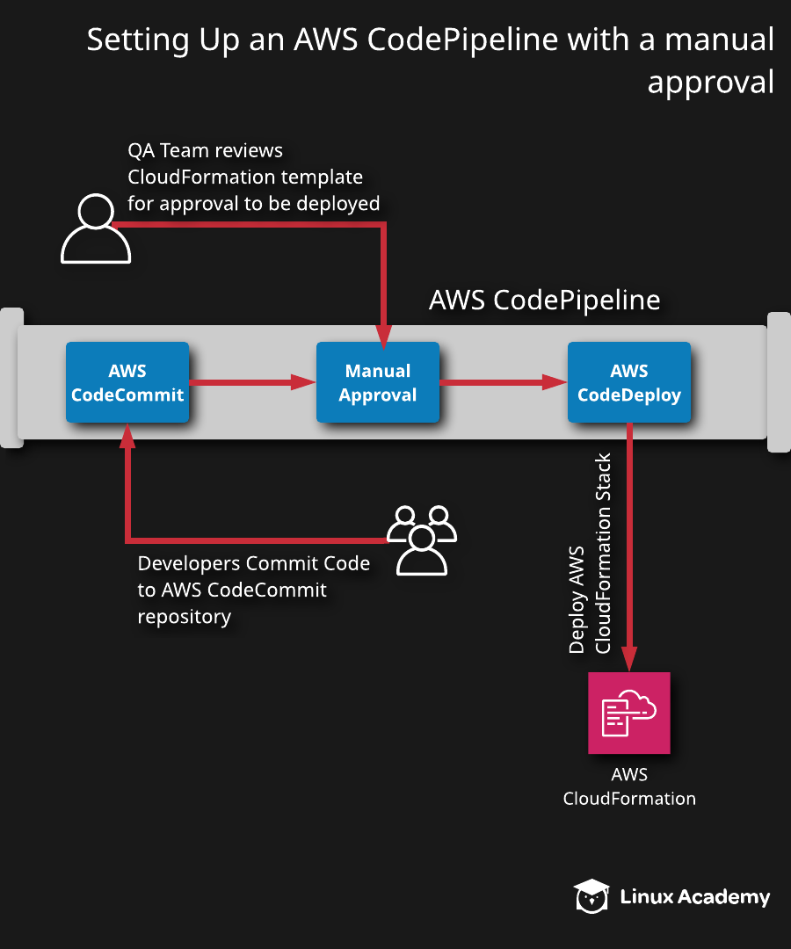
Additional Information and Resources
Our lab use case involves solving a pending problem with our code deployment pipeline. There have been a series of deployments that resulted in unexpected downtime to our client's web application. There have been cases where our QA team did not approve source code before being deployed to the production environment. Our management team has instructed our DevOps team to implement an approval process to keep this from reoccurring. Our solution is to build an AWS CodePipeline pipeline and add a stage that requires manual approval before deploying the source code to production.
Luckily, AWS CodePipeline enables us to easily implement a manual approval process. In this lab, we will build an AWS CodePipeline pipeline that will deploy a web application. We will build in a stage with a manual approval action right after the code repository and before the deployment stage.
Log in to the live AWS environment using the credentials provided.
Make sure you're in the N. Virginia (us-east-1) region throughout the lab.
Download the file needed for this lab: https://github.com/natonic/Developer-Tools-Deep-Dive/tree/master/Labs/CodePipelineWithManualApproval

Setting Up an AWS CodePipeline with a Manual Approval

Introduction
AWS CodePipeline is a native AWS solution that provides a continuous integration and continuous deployment pipeline offering to its clients. In this hands-on lab, we will implement AWS CodePipeline to deploy AWS infrastructure through AWS CloudFormation. We will add an action to our AWS CodePipeline that requires a manual approval intended to have any code commits reviewed prior to being deployed.

Solution
Log in to the live AWS environment using the credentials provided. Make sure you're in the N. Virginia (us-east-1) region throughout the lab.
Download the file needed for this lab at the lab GitHub page.

Create an AWS IAM Role
- From the AWS console, navigate to Identity and Access Management (IAM).
- Click Roles in the left-hand menu.
- Click Create role.
- Select CloudFormation as the service that will use this role.
- Click Next: Permissions.
- Select the checkbox for the AdministratorAccess permissions policy.
- Click Next: Tags > Next: Review.
- Enter "pipelineperms4CF" as the role name.
- Click Create role.

Create an AWS CodeCommit Repository and SNS Topic
- Download the file listed in the lab instructions for later use in the lab.
- From the AWS console, navigate to CodeCommit and click Create repository.
- Enter "pipeline4cf" as the repository name.
- Click Create.
- Click Add file > Upload file.
- Click Choose file.
- Select the s3Retain.yaml file (the one downloaded from GitHub at the start of the lab).
- Enter your name as the author name.
- Enter your email address as the email address.
- Click Commit changes.
- Navigate to Simple Notification Service (SNS).
- In the Create topic box on the main SNS page, enter "manualapprove" as the topic name.
- Click Next step.
- Accept the defaults on the next page by clicking Create topic.
- Click Create subscription.
- Choose Email as the protocol.
- Enter your email address as the endpoint.
- Click Create subscription.
- Navigate to your inbox, open the AWS Notification - Subscription Confirmation message, and click the Confirm subscription link.

Create an AWS CodePipeline Pipeline
- Navigate to CodePipeline.
- Click Create pipeline.
- Enter "ManualApprove4CF" as the pipeline name.
- Ensure New service role is selected.
- Ensure Allow AWS CodePipeline to create service role so it can be used with this new pipeline is checked.
- Expand the Advanced settings section and ensure the Default location and Default AWS Managed Key options are selected.
- Click Next.
- On the Add source stage page, set the following values:
  - Source provider: AWS CodeCommit
  - Repository name: pipeline4cf
  - Branch name: master
  - Change detection options: Amazon CloudWatch Events (recommended)
- Click Next > Skip build stage > Skip.
- On the Add deploy stage page, set the following values:
  - Deploy provider: AWS CloudFormation
  - Region: US East - (N. Virginia)
  - Action mode: Create or update a stack
  - Stack name: deploywithmanualapprove
  - Artifact name: SourceArtifact
  - File name: S3Retain.yaml
  - Role name: pipelineperm4cf
- Click Next > Create pipeline.
- Click the AWS CloudFormation link in the Deploy panel.
- Once CloudFormation shows complete, return to the CodePipeline service and verify the manualapprove pipeline status shows Succeeded in the Deploy panel.
- Select our pipeline.
- Click Edit.
- Click + Add stage between the Source and Deploy panels.
- Enter "manualapprove" as the stage name and click Add stage.
- Click + Add action group.
- In the Edit action dialog box, set the following values:
  - Action name: manualapproval
  - Action provider: Manual approval
  - SNS topic ARN: Select the listed SNS topic ARN we created earlier
- Click Done > Save > Save.
- Click Release change to restart the pipeline.
- Click Release.
- Navigate to your inbox, and open the APPROVAL NEEDED... message to see what your team would receive in a real-world environment.
- Navigate back to Code Pipeline.
- Click Review in the Manual approve panel.
- Enter "Looks good — approved." in the comments, and click Approve.

Conclusion
Congratulations on successfully completing this hands-on lab!

